EXPT NO: 9 | MINI PROJECT  HEALTHCARE DATAANALYTICS

AIM:
To develop an interactive Healthcare Data Analytics Dashboard using Power BI to analyze patient information, medical conditions, hospital admissions, length of stay, billing, insurance providers, and test results.

Procedure

- Import the Healthcare Dataset into Power BI and Tableau.
- Clean and transform the data using Power Query in Power BI and Data Source in Tableau.
- Check and correct the data types and remove unwanted or duplicate data.
- . Create required calculated fields such as Age Group and Length of Stay.
- Create the required data model and relationships in Power BI.
- Create required DAX measures and KPIs in Power BI.
- Create calculated fields and required measures in Tableau.
- Create charts for patients, medical conditions, admissions, hospitals, billing, insurance, and test results.
- Add cards, KPIs, slicers, filters, and drill-downs in Power BI.
- Add filters, dashboards, and interactive visualizations in Tableau.
- Design and format the dashboards in both Power BI and Tableau.

12. Analyze the visualizations and identify important healthcare insights.

13. Present the final results through the interactive dashboards.

- End.

Architecture:

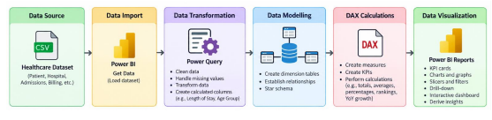

PROGRAM:

import pandas as pd

from sqlalchemy import create_engine, text

# Load dataset

df = pd.read_csv("healthcare_dataset.csv")

# Create a copy for processing

healthcare = df.copy()

# Remove duplicate records

healthcare.drop_duplicates(inplace=True)

# Handle missing values

healthcare["Name"] = healthcare["Name"].fillna("Unknown")

healthcare["Doctor"] = healthcare["Doctor"].fillna("Unknown")

healthcare["Hospital"] = healthcare["Hospital"].fillna("Unknown")

healthcare["Insurance Provider"] = healthcare["Insurance Provider"].fillna("Unknown")

healthcare["Medication"] = healthcare["Medication"].fillna("Unknown")

healthcare["Test Results"] = healthcare["Test Results"].fillna("Unknown")

# Convert date columns

healthcare["Date of Admission"] = pd.to_datetime(healthcare["Date of Admission"])

healthcare["Discharge Date"] = pd.to_datetime(healthcare["Discharge Date"])

# Create Length of Stay

healthcare["Length of Stay"] = (

healthcare["Discharge Date"] - healthcare["Date of Admission"]

).dt.days

# Create Age Group

healthcare["Age Group"] = pd.cut(

healthcare["Age"],

bins=[0, 17, 30, 45, 60, 150],

labels=["0-17", "18-30", "31-45", "46-60", "60+"]

)

# Standardize column names

healthcare.columns = (

healthcare.columns

.str.lower()

.str.strip()

.str.replace(" ", "_")

)

# Display original and cleaned shape

print("Original Shape:", df.shape)

print("Cleaned Shape:", healthcare.shape)

healthcare.head()

username = "root"

password = "YOUR_MYSQL_PASSWORD"

host = "localhost"

port = 3306

# Connect to MySQL database

db_engine = create_engine(

f"mysql+pymysql://{username}:{password}@{host}:{port}/healthcare_analytics"

)

# Load cleaned data into MySQL

healthcare.to_sql(

"healthcare_data",

con=db_engine,

if_exists="replace",

index=False,

chunksize=5000

)

print("Data loaded successfully into MySQL.")

# Verify data load

pd.read_sql(

"SELECT COUNT(*) AS total_rows FROM healthcare_data",

db_engine

)

Total Patients =

COUNTROWS(FactHealthcare)

Total Billing =

SUM(FactHealthcare[billing_amount])

Average Billing =

AVERAGE(FactHealthcare[billing_amount])

Average Age =

AVERAGE(FactHealthcare[age])

Average Length of Stay =

AVERAGE(FactHealthcare[length_of_stay])

Emergency Admissions =

CALCULATE(

[Total Patients],

FactHealthcare[admission_type] = "Emergency"

)

Emergency Admission Rate =

DIVIDE(

[Emergency Admissions],

[Total Patients]

)

Abnormal Tests =

CALCULATE(

[Total Patients],

FactHealthcare[test_results] = "Abnormal"

)

Abnormal Test Rate =

DIVIDE(

[Abnormal Tests],

[Total Patients]

)

Maximum Billing =

MAX(FactHealthcare[billing_amount])

Minimum Billing =

MIN(FactHealthcare[billing_amount])

Previous Year Billing =

CALCULATE(

[Total Billing],

SAMEPERIODLASTYEAR(DimDate[Date])

)

Billing YoY Growth % =

DIVIDE(

[Total Billing] - [Previous Year Billing],

[Previous Year Billing]

)

OUTPUT:

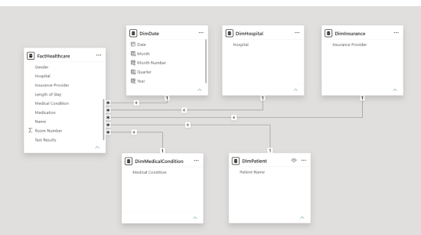

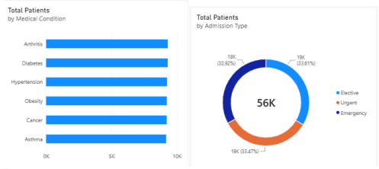
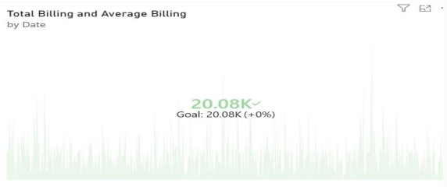

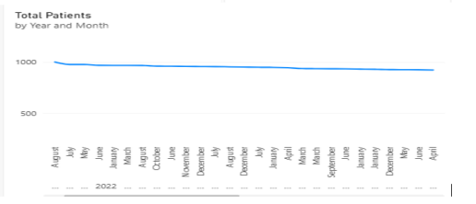

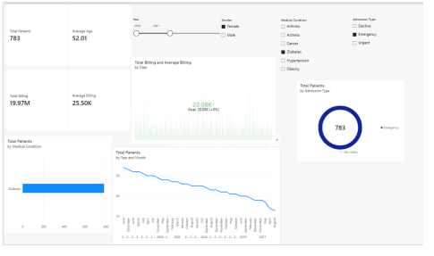

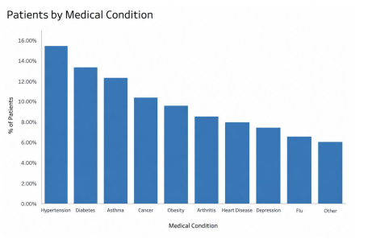

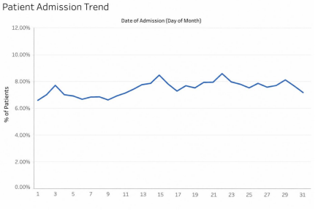

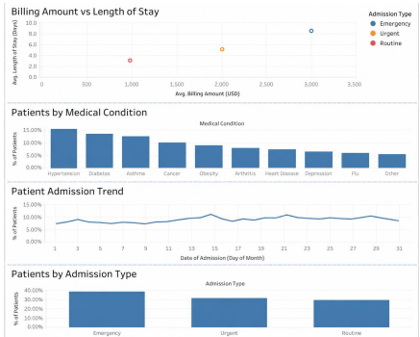

RESULT:
Thus, the Indian healthcare data was successfully analyzed using MySQL and visualized using Power BI. The project helped to identify patterns in patient demographics, diseases, treatments, treatment outcomes, BMI, and insurance coverage. The interactive dashboard provides a simple and clear way to understand the healthcare data.

